**SIT-TO-STAND OPTIONS**

**The relationship between sitting for long periods of time and poor health are well known. However, standing in one place for long periods of time poses its own health risks. Alternating positions between sitting and standing is optimal. Research has shown that walking for just 2-3 minutes every 30 minutes can be as beneficial as alternating between sitting and standing positions.**

**If you would like to explore a sit-to-stand workstation, which allows you to continue working while changing position, there are many options. EHRS does not recommend purchasing a sit-to-stand workstation until you know if the product will fit your space and you have consulted with your physician. EHRS does not provide sit-to-stand workstations. You must work with your departmental purchasing office.**

**In the EHRS office we have:**

**The** [**Ergotron S-series**](https://www.officedepot.com/catalog/search.do?Ntt=ergotron+s-series&searchSuggestion=true)**, available through Office Depot**

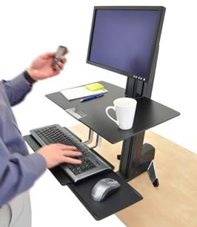

[**The Varidesk**](https://www.varidesk.com/)

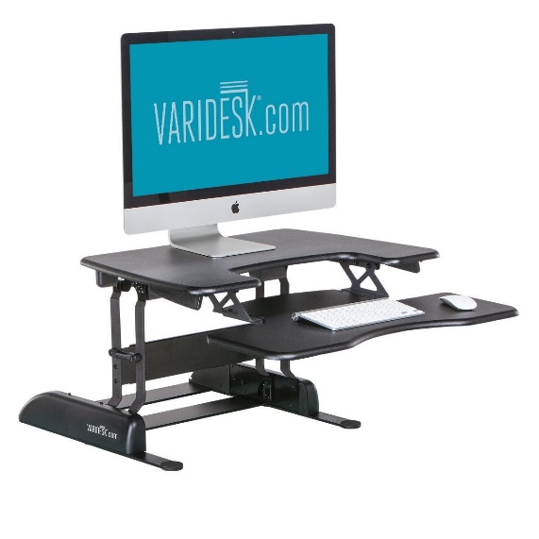

**The HiLo electronic height adjustable table available through** [**Kershner Office Furniture**](http://www.kershneroffice.com/products.html)**.**

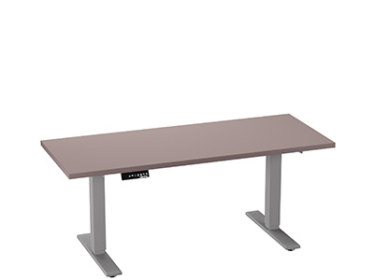

**The Office Depot catalog carries a the** [**3M Sit/Stand keyboard tray**](https://www.officedepot.com/a/products/875257/3M-SitStand-Adjustable-Keyboard-Tray-Black/) **that rises above the desk for standing (Item # 875257). In this case you may need to purchase a monitor arm as well.**

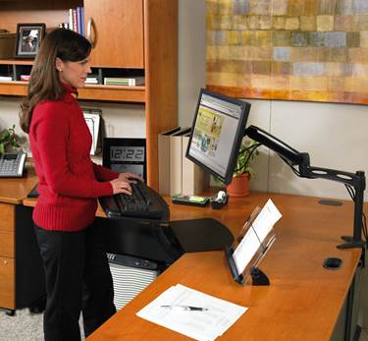

**If you would like to schedule a time to visit the EHRS office and look at these options please contact 215-898-4453.**