Entering Radioactive Waste Pickup Requests

- Log in with normal PI user name and password
  - https://ehrs.admin.upenn.edu/RadSaf
- Click on the “Radioactive Waste Pickup Request” icon
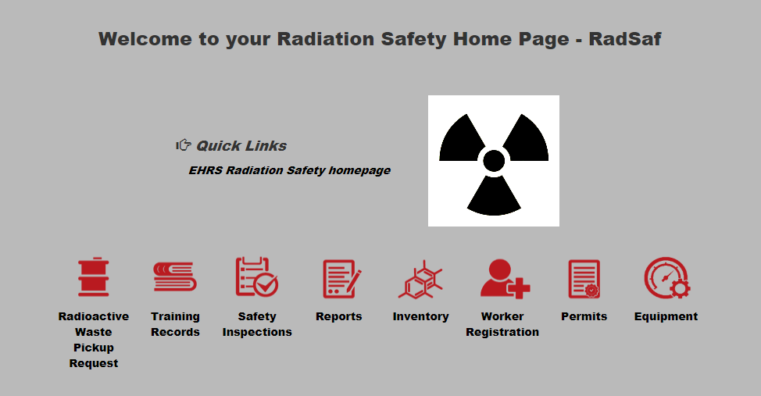
- Click on “Add a Waste Request”
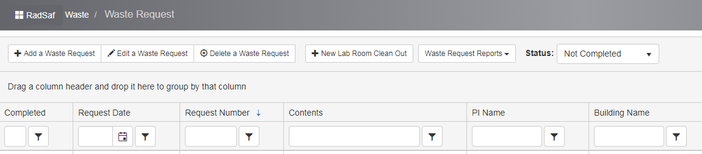
- If it is your first time logging in, you will be asked to complete a Waste Profile. This will include the location of waste pick up. This can be edited at any time if the pickup location changes.

  - To change the contact after a Waste Profile has already been created:
    - Select “Edit Profile” and enter the first and last name of the new contact along with an updated phone number and email address.
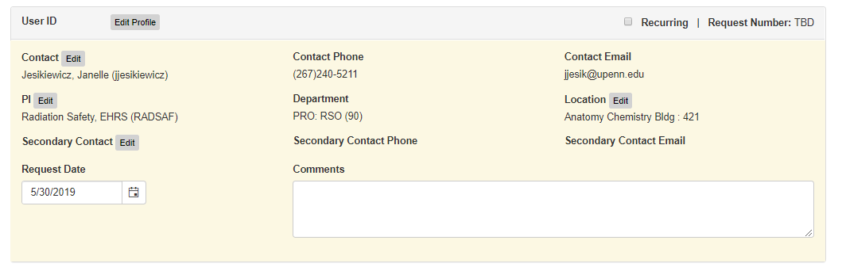
  - To update the pick-up location select the “Edit” button next to location
  - The "Secondary Contact" field may be used to add an additional person of contact for the waste pickup requests.
- For each container enter:
  - Physical Form
    - Select “Dry”, “Liquid”, “LSV” (liquid scintillation vials), or “Sealed Sources” from the dropdown box
    - Select the “Container Type” from the dropdown box for the type and volume of waste to be picked-up
    - If Liquid or LSV (liquid scintillation vials) is selected you must include non-radioactive components and percentage of each in the solution
      - Check the box next to “Must include non-rad components for liquid and scintillation vial waste (include % of each)” and then select “Edit”.
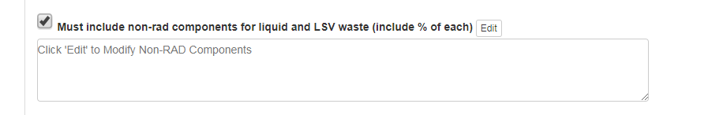
        - Enter the first constituent name/percentage and then select “Add” for each additional constituent. Click save when done.
        - Example:
          - Acetonitrile 50%, Water 50%
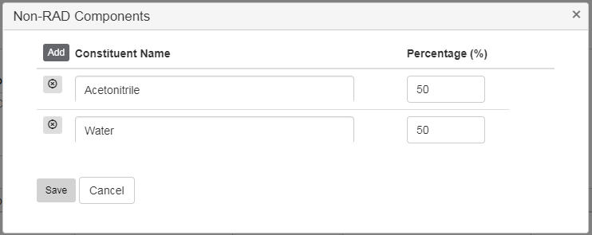
  - Container contents
    - Click under “Isotope” and a drop down box will appear with authorized isotopes under your license. Select the isotope.
    - Click under “Isotope Activity” and enter the activity in mCi
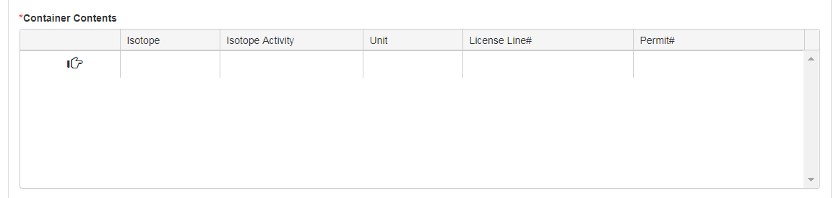
- If there are multiple waste items to be picked-up, click “Add Container” from the bottom of the screen for each additional item.
- Click “Save” from the bottom of the screen when finished.
- Click on “Waste Request Reports” & then “RAM Waste Tag”
- Print the RAM Waste Tag and attach each tag to the bags of waste

